Financial Transaction pattern analysis
A Project-Based Report Big Data Analytics Submitted in partial fulfillment of the requirements for the award of the degree of

BACHELOR OF TECHNOLOGY
In

BIG DATA ANALYTICS

By
BETHI IKSHITHA- 2320030140
ANANYA AREKATLA-2320030254

Under the Guidance of
Dr. Venkateswara Rao K
Associate Professor



DEPARTMENT OF COMPUTER SCIENCE AND ENGINEERING
KONERU LAKSHMAIAH EDUCATION FOUNDATION
(DEEMED TO BE UNIVERSITY)
BOWRAMPET, HYDERABAD-500043, TELANGANA, INDIA.
OCTOBER - 2025

DECLARATION

The Project-Based Report Big Data analytics entitled “Financial Transaction Pattern Analysis” is a record of bonafide work of Bethi Ikshitha-2320030140, Ananya arekatla-2320030254, submitted in partial fulfillment of the requirements for the award of B. Tech in Big data analytics to the Koneru Lakshmaiah Education Foundation. The results embodied in this report have not been copied from any other department/University, /Institute.

Bethi Ikshitha-2320030140
Ananya arekatla-2320030254

CERTIFICATE

This is to certify that the project-based report Big Data Analytics entitled “Financial transaction pattern" is bonafide work done and submitted by Bethi Ikshitha-2320030140,Ananya Arekatla-2320030254, in partial fulfillment of the requirements for the award of the degree of BACHELOR OF TECHNOLOGY in the Department of Computer Science and Engineering, Koneru Lakshmaiah Education Foundation, during the academic year 2025-2026.

Guide HOD
Dr. Venkateswara Rao K Dr. Venkateswara Rao P
Associate Professor Associate Professor
Dept. of CSE Dept. of CSE

ACKNOWLEDGEMENT

With great pleasure, we want to take this opportunity to express our heartfelt gratitude to all the people who helped in making this project a grand success.
We are grateful to , Dr. Venkateswara Rao K Associate Professor, Department of Computer Science and Engineering, for his valuable technical suggestions and guidance during the execution of this project work.
We want to thank Venkateswara Rao P Associate Professor ,Head of the Department of Computer Science and Engineering , Koneru Lakshmaiah Education Foundation, who is the primary driving force behind completing my project work successfully.
We are very grateful to Dr.Raghavendra , Coordinator-Academics, Koneru Lakshmaiah Education Foundation, for his constant support and motivation in successfully carrying out the project work.
We are highly indebted to Koteshwar Rao, Principal, Koneru Lakshmaiah Education Foundation, for permitting us to carry out this project in a successful and fruitful way.
We want to thank the Teaching & Non- teaching staff of the Department of Artificial Intelligence and Data Science for their cooperation.
Finally, we thank our parents, who have stood behind us at different project stages. We sincerely acknowledge and thank those who directly and indirectly support completing this project
Bethi Ikshitha-2320030140
Ananya Arekatla -2320030254

TABLE OF CONTENTS

S.No | Contents | Page no
1 | Abstract | 6
2 | Introduction | 7
3 | Literature survey | 9
4 | Hardware and Software requirements | 12
5 | Implementation | 16
6 | Experimentation and Code | 18
7 | Results | 21
8 | Conclusion | 24
19 | References | 25

ABSTRACT

The rapid growth of digital payment systems and online banking has led to the generation of
massive volumes of financial transaction data, making effective analysis critical for
understanding transaction behaviour, identifying meaningful patterns, and detecting
suspicious activities. This project, Financial Transaction Pattern Analysis Using Big Data
Analytics, focuses on the structured analysis of large, real-world, and unclean financial
datasets. The dataset used in this study is obtained from a publicly available source and
contains common data quality issues such as missing values, duplicate records, and
inconsistent formats. To address these challenges, data preprocessing and cleaning techniques
including data imputation, duplicate removal, normalization, and format standardization are
applied to enhance data reliability and consistency. Following preprocessing, exploratory data
analysis (EDA) and descriptive analytics are performed to examine transaction frequency,
high-value transactions, and overall customer behaviour. Big Data Analytics concepts are
employed to manage challenges related to data volume, variety, and veracity. Analytical
models such as clustering techniques (e.g., K-means) for customer segmentation, statistical
trend analysis, and rule-based and anomaly detection models are used to identify unusual
transaction patterns. Additionally, classification and regression models support behaviour
prediction and pattern identification. The outcomes of the analysis demonstrate how
meaningful insights can be extracted from raw financial data, emphasizing the importance of
data preprocessing and analytical modelling in enhancing monitoring, analysis, and decision-
making within banking and financial institutions.

INTRODUCTION

In today’s digital era, financial institutions generate a massive volume of transaction data every second through online banking, digital payments, ATM transactions, credit and debit card usage, and electronic fund transfers. Managing and analyzing such large-scale financial data using traditional data processing techniques has become increasingly difficult. As the volume, variety, and velocity of financial data continue to grow, organizations require efficient analytical methods to process, understand, and extract meaningful insights from the data. This has led to the growing importance of Big Data Analytics in the financial sector.
The project titled “Financial Transaction Pattern Analysis Using Big Data Analytics” focuses on analyzing financial transaction data to identify useful patterns, understand customer behavior, and study transaction trends. The main objective of this project is to process and analyze financial transaction data using data analytics techniques in order to derive meaningful insights that can support financial monitoring and decision-making. By applying analytical methods and visualization techniques, the project demonstrates how large-scale financial datasets can be efficiently examined to identify spending behavior, transaction frequency, and high-value transactions.
In this project, the financial transaction dataset is analyzed using data analytics tools and techniques. The implementation is carried out using R programming language for data preprocessing, statistical analysis, and visualization. Various transaction attributes such as transaction amount, transaction type, channel, location, customer age, account balance, and transaction duration are analyzed to understand transaction behavior and identify important patterns. The project also uses charts and graphs to represent the results clearly and make the insights easier to interpret.
Problem Description and Objectives:
Financial organizations process thousands to millions of transactions every day through online banking systems, digital payment applications, ATM withdrawals, and electronic fund transfers. Managing and analyzing such large volumes of financial data using traditional methods is inefficient, time-consuming, and often difficult to scale. As the amount of data increases, understanding customer spending patterns, identifying transaction trends, and detecting unusual financial activities become more challenging. Conventional data processing systems are not always capable of handling such large datasets efficiently or extracting meaningful insights from them.To overcome these challenges, Big Data Analytics provides an efficient and scalable approach for processing and analyzing large financial datasets. Big Data techniques help organizations store, organize, process, and interpret large volumes of structured and semi-structured transaction data. These analytical methods make it possible to identify transaction patterns, monitor financial behavior, and gain valuable insights that support better decision-making in financial systems.

The main objective of this project is to analyze financial transaction data and extract meaningful insights that can support financial understanding and analysis. The project focuses on processing a large transaction dataset and performing analysis on important attributes such as transaction amount, transaction type, channel, location, customer age, account balance, and transaction duration. It aims to identify transaction patterns such as debit and credit trends, location-wise transaction distribution, and channel-based usage behavior. Another important objective of the project is to identify high-value transactions and study patterns that may indicate unusual financial activity. In addition, the project uses data visualization techniques such as histograms, bar charts, and line graphs to present transaction insights in an easily understandable form. Through this project, the importance of Big Data Analytics in handling large-scale financial data and enabling efficient, meaningful, and scalable transaction analysis is clearly demonstrated.

LITERATURE SURVEY

The rapid growth of digital banking, online transactions, mobile payments, and cashless financial systems has led to an exponential increase in financial data. Financial institutions generate large volumes of transaction records every day through online banking systems, ATM withdrawals, credit and debit card usage, and fund transfers. Traditional data processing techniques are no longer sufficient to handle such large-scale and continuously growing datasets efficiently. As a result, Big Data Analytics has emerged as an essential approach for analyzing financial transactions and extracting meaningful insights from them.
Financial transaction analytics has become a major area of research due to its importance in understanding customer spending behavior, identifying transaction patterns, detecting abnormal financial activities, and improving decision-making in financial systems. Researchers have shown that Big Data technologies and analytics techniques can process massive datasets more efficiently than conventional systems. These methods help organizations identify trends, monitor user behavior, and improve operational performance in financial applications.

Big Data Analytics in Financial Data Processing
Big Data Analytics has significantly changed the way financial data is stored, processed, and analyzed. Financial institutions often deal with high volumes of structured and semi-structured data, making traditional database systems less effective for large-scale analysis. Researchers have emphasized that Big Data technologies provide improved scalability, faster processing, and better storage capabilities for handling financial transaction datasets.
Several studies have shown that analytics tools and distributed processing techniques can efficiently process large financial datasets and reduce the time required for analysis. By applying Big Data methods, organizations can identify transaction trends, customer behavior, and account activity patterns more effectively. This has made Big Data Analytics a valuable tool in modern financial systems.

Transaction Pattern Analysis in Financial Systems
Transaction pattern analysis is an important application of Big Data Analytics in the financial domain. Researchers have studied how transaction amount, transaction frequency, transaction type, and customer behavior can be analyzed to identify meaningful financial patterns. By examining transaction records, organizations can understand how customers use financial services and how transaction behavior varies across accounts, channels, and locations.
Several researchers have highlighted the importance of analyzing transaction trends for better financial monitoring and customer behavior understanding. Transaction pattern analysis helps identify common spending ranges, frequently used transaction channels, and location-based transaction behavior. Such insights support better financial planning and improved monitoring systems.

Detection of High-Value and Unusual Transactions
One of the important research areas in financial analytics is the identification of high-value or unusual transactions. Researchers have observed that certain financial activities may exhibit abnormal characteristics such as unusually high transaction amounts, repeated transaction attempts, unusual transaction duration, or unexpected account behavior. Identifying such patterns helps organizations improve financial monitoring and risk assessment.
Different analytical approaches have been proposed in previous studies to identify unusual financial activities. Some studies focus on threshold-based analysis, where transactions exceeding a certain amount are marked for further observation. Other works use statistical analysis and pattern recognition techniques to study deviations in transaction behavior. These methods are useful in understanding significant transaction activities and identifying patterns that may require attention.

Role of Data Visualization in Financial Analytics
Data visualization plays a crucial role in financial transaction analysis by converting large and complex datasets into meaningful graphical representations. Researchers have pointed out that visual analytics makes it easier to understand trends, detect patterns, and interpret financial data efficiently. Charts and graphs help simplify transaction analysis and make the results easier to understand for both technical and non-technical users.
In financial analytics, commonly used visualization methods include histograms, bar charts, line graphs, and pie charts. These visual representations help analyze transaction amount distribution, account activity, transaction type trends, and location-wise financial behavior. Visualization is therefore considered an essential component of modern financial data analysis systems.

Comparative Observations from Existing Studies
A review of existing literature shows that Big Data Analytics provides several advantages over traditional data processing methods in financial applications. Traditional systems often struggle with large-scale datasets due to limitations in storage, processing speed, and scalability. In contrast, Big Data techniques support efficient handling of high-volume transaction data and enable faster analytical operations.
Researchers have also observed that combining data preprocessing, statistical analysis, and visualization methods produces effective results in financial transaction analysis. Such approaches help in extracting useful patterns from transaction data without requiring overly complex infrastructure. Existing studies indicate that financial transaction analytics can be significantly improved by applying modern Big Data tools and analytical techniques.

Conclusion
The literature clearly demonstrates that Big Data Analytics has become highly important in modern financial systems. From transaction pattern analysis to high-value transaction identification and customer behavior understanding, previous studies have shown the effectiveness of analytics techniques in handling large-scale financial data. The use of analytical methods and visualization tools helps transform raw transaction data into meaningful insights that support better financial monitoring and decision-making..

HARDWARE AND SOFTWARE REQUIREMENTS:

The Financial Transaction Pattern Analysis Using Big Data Analytics project does not require very high-end hardware, as the implementation is mainly carried out using R programming language and data analytics libraries. A basic system with moderate specifications is sufficient to perform data preprocessing, analysis, and visualization smoothly. The following hardware and software requirements are suitable for implementing this project.

Hardware Specifications

Processor
A system with an Intel Core i3 processor or equivalent is sufficient for running the project. For better performance and smoother execution of data analysis and graph generation, an Intel Core i5 or higher is recommended. Since the project mainly involves dataset processing and visualization, a mid-range processor is enough for efficient execution.

RAM
A minimum of 4 GB RAM is required to run the development environment and perform data analysis operations. However, 8 GB RAM or above is recommended for smoother performance, especially while handling larger datasets, generating graphs, and working with multiple files or applications simultaneously.

Storage
The project does not require very high storage capacity, but at least 500 MB to 1 GB of free disk space is recommended for:
- Dataset storage
- R / RStudio installation
- Required packages and libraries
- Temporary files and generated outputs

Graphics
No dedicated graphics card is required for this project. The integrated graphics available in modern processors are sufficient, as the project mainly focuses on data analysis and visualization rather than graphical rendering or advanced multimedia processing.

Operating System
The project is compatible with the following operating systems:
- Windows
- Linux
- macOS
Since the project is developed using standard data analytics tools, it can be executed on any of the above operating systems without major compatibility issues.

Software Requirements
The project uses open-source tools and data analytics technologies to process and analyze financial transaction data efficiently.

Programming Language
- R Programming Language
R is used in this project for data preprocessing, statistical analysis, transaction pattern identification, and visualization.

Development Environment
- RStudio – Main development and execution platform
- Jupyter Notebook / Google Colab (Optional) – Alternative environment for running R code
RStudio is recommended because it provides an easy and user-friendly interface for writing, running, and visualizing R code.

Libraries and Packages
The following R libraries are used in the project:
- ggplot2 – For data visualization
- dplyr – For data manipulation and analysis
- readr – For reading and importing datasets
- lubridate – For handling date and time columns
- RColorBrewer – For generating colorful charts and graphs
These libraries help in data cleaning, statistical analysis, transaction pattern analysis, and graphical representation of results.

Dataset
- Bank Transaction Dataset (CSV format)
The dataset used in the project contains financial transaction details such as:
- Transaction ID
- Account ID
- Transaction Amount
- Transaction Date
- Transaction Type
- Location
- Device ID
- Channel
- Customer Age
- Account Balance
- Login Attempts
- Transaction Duration

This dataset is used for identifying transaction patterns, analyzing customer behavior, and detecting high-value transactions.

Visualization Tools
The project uses visualization tools available in R through the ggplot2 package to represent transaction patterns clearly. The following graphs are generated:
- Histogram
- Bar Chart
- Line Graph
- Horizontal Bar Chart
These visualizations help in understanding transaction amount distribution, transaction type frequency, location-wise analysis, and daily transaction trends.

Conclusion
With the above hardware and software configuration, the Financial Transaction Pattern Analysis Using Big Data Analytics project can be executed efficiently. The project does not require high-end hardware and can be implemented on a basic personal computer or laptop. By using R programming language and data analytics libraries, the system provides an effective and simple platform for analyzing financial transaction datasets and extracting meaningful insights.

IMPLEMENTATION

The implementation of the Financial Transaction Pattern Analysis Using Big Data Analytics project focuses on analyzing large-scale financial transaction data using data analytics techniques. The system is designed to load, preprocess, analyze, and visualize financial transaction data efficiently in order to identify useful patterns and trends. The complete implementation is carried out using R programming language and data analytics libraries such as dplyr, ggplot2, readr, and lubridate.
The implementation process is divided into multiple stages, including dataset representation, data loading, preprocessing, analytical computation, transaction pattern analysis, high-value transaction detection, and visualization. Each stage plays an important role in ensuring that the financial transaction data is processed accurately and meaningful insights are extracted effectively.

1. Data Representation and Dataset Description
The dataset used in this project consists of financial transaction records representing banking and digital transaction data. Each record corresponds to a single transaction and contains various attributes that describe transaction behavior and customer-related details.
The dataset includes the following important attributes:
- Transaction ID – Unique identifier for each transaction
- Account ID – Customer account number
- Transaction Amount – Amount involved in the transaction
- Transaction Date – Date and time of the transaction
- Transaction Type – Debit or Credit
- Location – City or place where the transaction occurred
- Channel – Mode of transaction (ATM, Online, POS)
- Customer Age – Age of the customer
- Customer Occupation – Occupation of the customer
- Login Attempts – Number of login attempts
- Account Balance – Available balance after transaction
- Transaction Duration – Time taken to complete the transaction
The dataset is stored in CSV format and is loaded into the system for further analysis.

2. Establishing the Analytical Environment
The implementation environment is created using R programming language and supporting analytics libraries. The analysis is performed using RStudio as the main development platform.

R Programming Language
R is used as the primary language for data preprocessing, statistical analysis, and graphical visualization. It provides powerful libraries for handling structured financial datasets and performing transaction analysis efficiently.

RStudio
RStudio is used as the main development and execution environment. It provides a user-friendly interface for writing R scripts, loading datasets, generating outputs, and visualizing results.

Libraries Used
The following R libraries are used in the project:
- dplyr – for data manipulation and grouping
- ggplot2 – for graphical visualization
- readr – for reading the dataset
- lubridate – for handling date and time columns
- RColorBrewer – for colorful chart generation
These tools and libraries provide an efficient environment for implementing the project.

3. Data Loading and Preprocessing
The dataset is loaded into the R environment using CSV file handling functions. Once loaded, the data is examined to understand its structure, column names, and statistical summary.
During preprocessing, the following operations are performed:
- Handling missing values
- Removing duplicate records
- Validating data types
- Formatting date and time columns
- Preparing attributes for analysis
This preprocessing stage ensures that the dataset is clean, consistent, and suitable for analytical operations. Clean data is essential for obtaining meaningful and accurate insights from financial transaction records.

4. Transaction Analysis and Processing
Once the data is loaded and preprocessed, several analytical operations are performed to extract useful insights from the financial transaction dataset.

Transaction Pattern Analysis
The system analyzes important transaction patterns such as:
- Debit and credit transaction distribution
- Location-wise transaction frequency
- Channel-based transaction behavior
- Transaction amount distribution
These analyses help in understanding customer transaction behavior, transaction trends, and frequently used transaction channels.

Customer Behavior Analysis
Customer behavior is studied using attributes such as:
- Transaction frequency
- Login attempts
- Customer age
- Occupation-wise transaction behavior
- Account balance patterns
This helps in understanding how different customer groups interact with financial systems and how transaction behavior varies across users.

5. High-Value Transaction Detection
One of the important parts of the implementation is identifying high-value transactions. Transactions exceeding a predefined threshold amount are filtered and analyzed separately. These transactions are important because they may indicate significant financial activity or unusual spending behavior.
High-value transaction detection helps in:
- Identifying transactions with unusually large amounts
- Studying abnormal financial behavior
- Supporting financial monitoring and analysis

This step provides useful insights into significant financial activities within the dataset.

6. Visualization and Result Analysis
The results obtained from the analysis are visualized using ggplot2 in R. Data visualization plays a crucial role in representing large and complex datasets in a simple and understandable form.
The following visualizations are generated in the project:
- Histogram showing transaction amount distribution
- Bar chart representing transaction type distribution
- Channel-wise transaction count graph
- Location-wise transaction distribution graph
- Occupation-wise transaction analysis chart
- Daily transaction trend graph
- Top 10 highest transactions chart

These graphical representations help in better understanding transaction trends, customer behavior, and financial activity patterns.

7. Output and Performance Evaluation
The system outputs include:
- Transaction pattern summaries
- Statistical analysis results
- High-value transaction records
- Graphical visualizations of financial data
- Analytical insights for understanding customer and transaction behavior
The performance of the system demonstrates that Big Data Analytics techniques significantly improve the ability to process, analyze, and interpret large-scale financial transaction data. Compared to manual or traditional approaches, this implementation provides faster analysis, better data organization, and clearer insight generation.

Conclusion
The implementation of the Financial Transaction Pattern Analysis Using Big Data Analytics system successfully demonstrates how financial transaction datasets can be processed and analyzed using data analytics techniques. By using R programming language and its analytical libraries, the system is able to identify transaction patterns, analyze customer behavior, detect high-value transactions, and generate meaningful visual insights.
This implementation shows the practical importance of Big Data Analytics in handling large-scale financial data efficiently and supports the use of data-driven approaches in financial monitoring and decision-making.

EXPEREMENTATION AND CODE:

The experimentation phase of this project was carried out to analyze the financial transaction dataset and extract meaningful insights using Big Data Analytics techniques. The implementation was performed using the R programming language along with analytical libraries such as dplyr, ggplot2, readr, lubridate, and RColorBrewer. The experiments were designed to study transaction patterns, customer behavior, high-value transactions, and transaction trends through both statistical analysis and visualization.
The dataset used in this project contains financial transaction records with multiple attributes such as Transaction ID, Account ID, Transaction Amount, Transaction Date, Transaction Type, Location, Channel, Customer Age, Customer Occupation, Login Attempts, Account Balance, and Transaction Duration. These attributes were analyzed to understand different dimensions of financial transactions and derive useful patterns.
The experimentation process was divided into multiple steps. Initially, the dataset was loaded into the R environment and examined to understand its structure, data types, and statistical summary. After this, preprocessing was carried out by checking for missing values, removing incomplete records, and eliminating duplicate rows. Date-related columns were converted into proper date-time format so that time-based analysis could be performed.
Further experiments were conducted to perform basic statistical analysis, including calculation of total transactions, average transaction amount, maximum transaction value, minimum transaction value, and average account balance. These statistics provided a general understanding of the financial dataset.
The project also included transaction type analysis to compare debit and credit transactions, channel-wise analysis to study ATM, Online, and POS transactions, location-wise analysis to identify cities with higher transaction frequency, and occupation-wise analysis to understand how transaction behavior differs across customer groups. In addition, high-value transactions were filtered using a threshold condition to identify significant financial activities. The top 10 highest transactions were also extracted separately for further observation.
To better understand transaction behavior over time, daily transaction trend analysis was performed by grouping transactions based on date. Finally, several colorful graphs and visualizations were generated to represent the results clearly. These visualizations helped in understanding transaction amount distribution, transaction type frequency, channel-based transaction behavior, location-wise trends, and daily transaction activity.
CODE:
Financial Transaction Pattern Analysis Using Big Data Analytics
library(ggplot2)
library(dplyr)
library(readr)
library(lubridate)
library(RColorBrewer)
transactions <- read.csv("/Users/bethiikshitha/Desktop/bank_transactions_data_2.csv", stringsAsFactors = FALSE)

# View first few rows
head(transactions)

str(transactions)
summary(transactions)
colnames(transactions)
dim(transactions)
4. Data Preprocessing

# Check missing values
colSums(is.na(transactions))

# Remove missing values
transactions <- na.omit(transactions)

# Remove duplicate rows
transactions <- distinct(transactions)

# Check cleaned dataset
head(transactions)
transactions$TransactionDate <- ymd_hms(transactions$TransactionDate)
transactions$PreviousTransactionDate <- ymd_hms(transactions$PreviousTransactionDate)

# Extract date only
transactions$DateOnly <- as.Date(transactions$TransactionDate)
cat("===== BASIC STATISTICS =====\n")
cat("Total Transactions:", nrow(transactions), "\n")
cat("Average Transaction Amount:", mean(transactions$TransactionAmount), "\n")
cat("Maximum Transaction Amount:", max(transactions$TransactionAmount), "\n")
cat("Minimum Transaction Amount:", min(transactions$TransactionAmount), "\n")
cat("Average Account Balance:", mean(transactions$AccountBalance), "\n\n")
transaction_type_count <- transactions %>%
group_by(TransactionType) %>%
summarise(Count = n())

print(transaction_type_count)
channel_count <- transactions %>%
group_by(Channel) %>%
summarise(Count = n())

print(channel_count)
location_count <- transactions %>%
group_by(Location) %>%
summarise(Count = n()) %>%
arrange(desc(Count))

print(location_count)
occupation_count <- transactions %>%
group_by(CustomerOccupation) %>%
summarise(Count = n()) %>%
arrange(desc(Count))

print(occupation_count)
high_transactions <- transactions %>%
filter(TransactionAmount > 1000)

cat("Number of High-Value Transactions:", nrow(high_transactions), "\n")
head(high_transactions)
top_transactions <- transactions %>%
arrange(desc(TransactionAmount)) %>%
head(10)

print(top_transactions)
daily_transactions <- transactions %>%
group_by(DateOnly) %>%
summarise(TransactionCount = n())

print(head(daily_transactions))
# 1. Transaction Amount Distribution
ggplot(transactions, aes(x = TransactionAmount)) +
geom_histogram(bins = 30, fill = "skyblue", color = "black") +
ggtitle("Transaction Amount Distribution") +
xlab("Transaction Amount") +
ylab("Frequency") +
theme_minimal()

# 2. Transaction Type Distribution
ggplot(transaction_type_count, aes(x = TransactionType, y = Count, fill = TransactionType)) +
geom_bar(stat = "identity") +
ggtitle("Transaction Type Distribution") +
xlab("Transaction Type") +
ylab("Count") +
scale_fill_brewer(palette = "Set2") +
theme_minimal() +
theme(legend.position = "none")
ggplot(channel_count, aes(x = Channel, y = Count, fill = Channel)) +
geom_bar(stat = "identity") +
ggtitle("Channel-wise Transaction Count") +
xlab("Channel") +
ylab("Count") +
scale_fill_brewer(palette = "Pastel1") +
theme_minimal() +
theme(legend.position = "none")
ggplot(location_count[1:10, ], aes(x = reorder(Location, Count), y = Count, fill = Location)) +
geom_bar(stat = "identity") +
ggtitle("Top 10 Locations by Transaction Count") +
xlab("Location") +
ylab("Count") +
coord_flip() +
scale_fill_brewer(palette = "Set3") +
theme_minimal() +
theme(legend.position = "none")
ggplot(occupation_count, aes(x = reorder(CustomerOccupation, Count), y = Count, fill = CustomerOccupation)) +
geom_bar(stat = "identity") +
ggtitle("Occupation-wise Transaction Count") +
xlab("Customer Occupation") +
ylab("Count") +
coord_flip() +
scale_fill_brewer(palette = "Paired") +
theme_minimal() +
theme(legend.position = "none")
ggplot(daily_transactions, aes(x = DateOnly, y = TransactionCount)) +
geom_line(color = "blue", linewidth = 1) +
ggtitle("Daily Transaction Trend") +
xlab("Date") +
ylab("Number of Transactions") +
theme_minimal()
ggplot(top_transactions, aes(x = reorder(TransactionID, TransactionAmount), y = TransactionAmount, fill = TransactionID)) +
geom_bar(stat = "identity") +
ggtitle("Top 10 Highest Transactions") +
xlab("Transaction ID") +
ylab("Transaction Amount") +
coord_flip() +
scale_fill_brewer(palette = "Accent") +
theme_minimal() +
theme(legend.position = "none")
cat("\n===== FINAL PROJECT INSIGHTS =====\n")
cat("Total Transactions:", nrow(transactions), "\n")
cat("Average Transaction Amount:", mean(transactions$TransactionAmount), "\n")
cat("Maximum Transaction Amount:", max(transactions$TransactionAmount), "\n")
cat("Minimum Transaction Amount:", min(transactions$TransactionAmount), "\n")
cat("Average Account Balance:", mean(transactions$AccountBalance), "\n")
cat("Number of High-Value Transactions:", nrow(high_transactions), "\n")
cat("Most Common Transaction Type:", names(sort(table(transactions$TransactionType), decreasing = TRUE))[1], "\n")
cat("Most Common Channel:", names(sort(table(transactions$Channel), decreasing = TRUE))[1], "\n")
cat("Most Active Location:", names(sort(table(transactions$Location), decreasing = TRUE))[1], "\n")

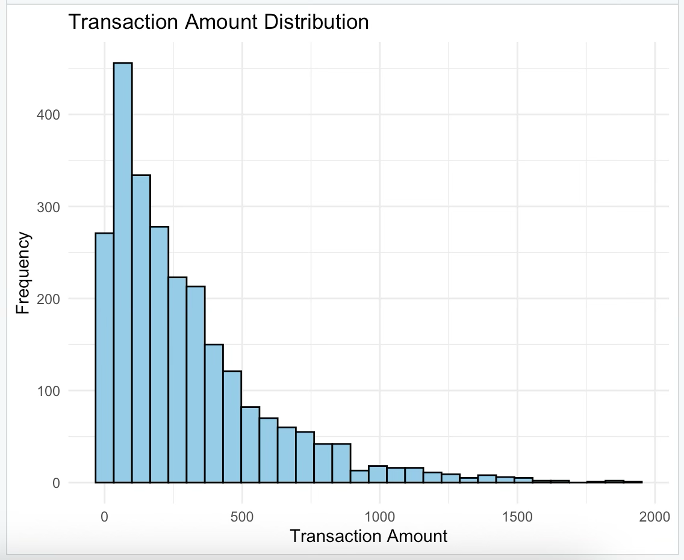
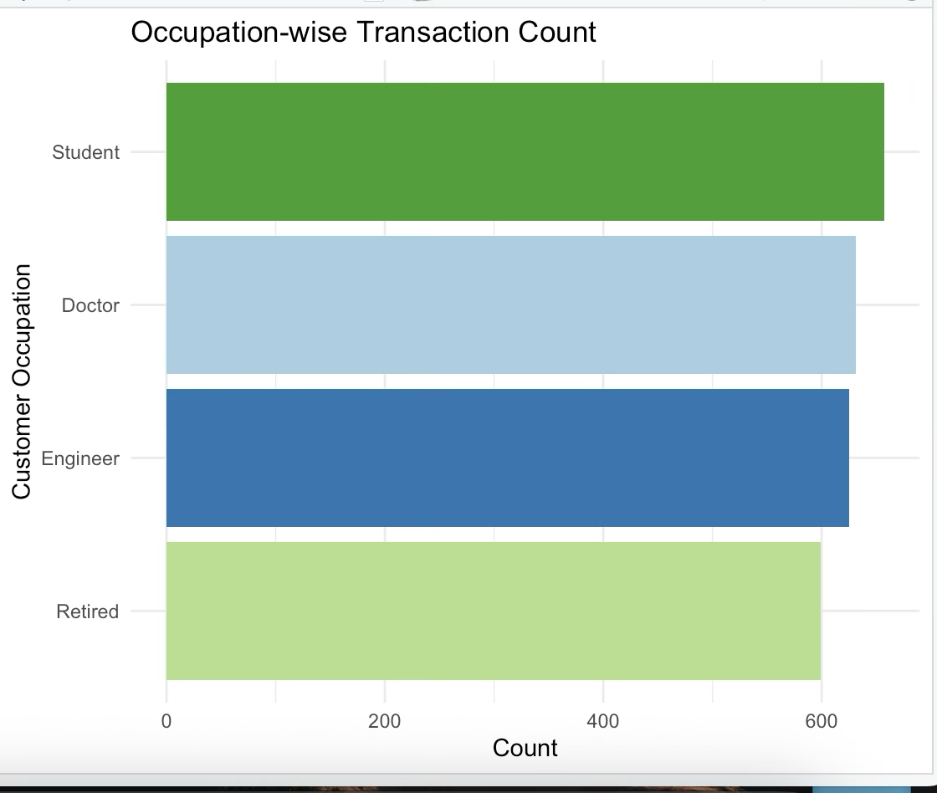
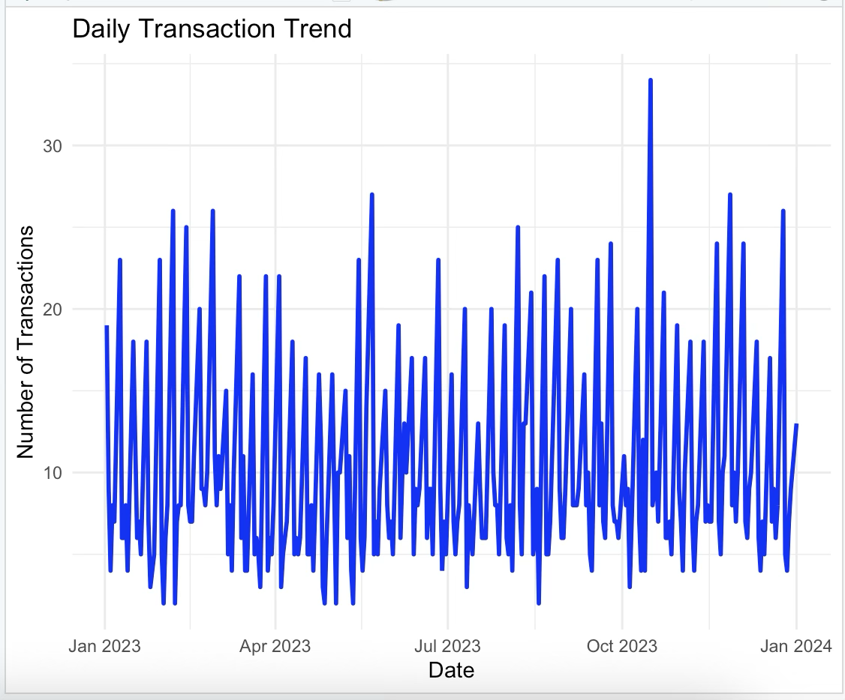
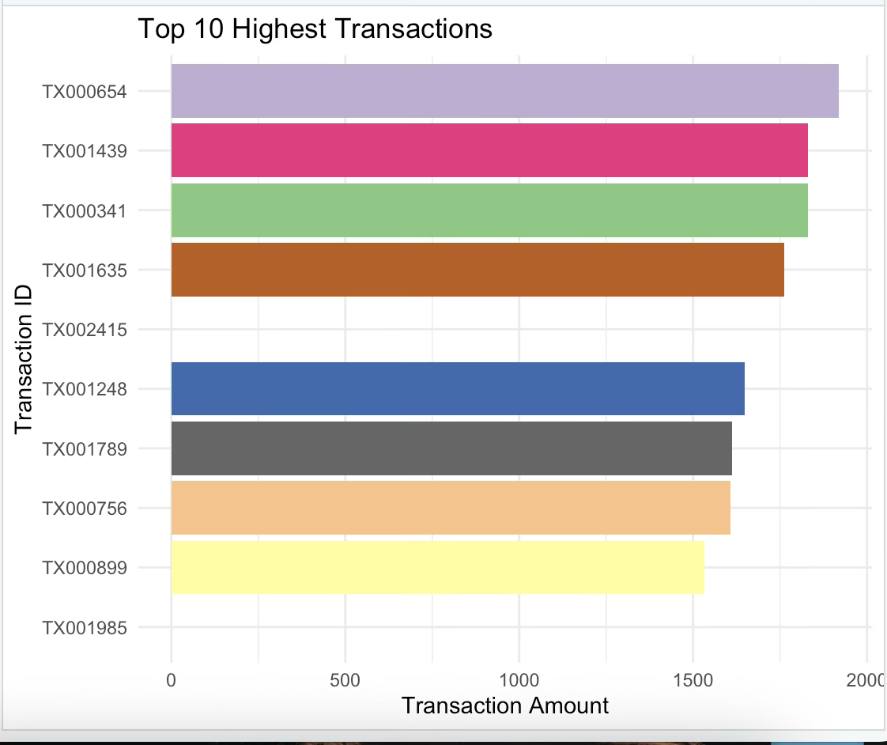

Conclusion of Experimentation
The experimentation phase of the project was successfully carried out using R programming language and data analytics libraries to analyze the financial transaction dataset. Through a series of analytical steps, the dataset was loaded, cleaned, processed, and examined to extract meaningful patterns and trends from financial transaction records. The implementation proved that large transaction datasets can be effectively handled using Big Data Analytics techniques.During experimentation, various analyses were performed, including transaction amount analysis, transaction type distribution, channel-wise transaction behavior, location-wise transaction frequency, occupation-wise transaction analysis, and high-value transaction detection. In addition, graphical visualizations such as histograms, bar charts, and line graphs were generated to represent the data clearly and make the analytical results easier to understand.The experimentation results demonstrated that the system is capable of identifying useful transaction patterns, understanding customer behavior, and highlighting significant financial activities. Overall, the experimentation phase confirmed that the proposed system works effectively for analyzing financial transaction data and supports the practical application of Big Data Analytics in financial data analysis and decision-making.

